CREATIVE TROMPE L’OEIL / MURALIST / ARTIST CV
Pandora
EDUCATION Bachelor of Visual Arts
Assorted technical training art/ design courses including the Community Arts in Place
EMPLOYER A Artist & More, Pandora’s Trompe L’oeil/Murals
CONTACT info@pandoramurals.com.au
0412821716 83324171
GALLERY Sydenham Rd, Norwood
WEB www.pandoramurals.com.au

My experience includes the National Heritage Listed Restoration of William Morris Wallpaper + Marble Fireplace at Auchendarroch; multitudes of murals both private commissions and public from large scale to budget art works; community and public art collaborating with disabled, disadvantaged, all ages from infants to elderly; sign writing; mosaics/crafts; art canvases using multi mediums and recycled art; sculpture repairs; art classes and I am sole-directed founder of my award-winning business through having vast versatility and best value.
I have also experience in a multitude of commissions for Adelaide City Council, Marion Council; Mitcham Council; Playford Council, Meningie Library, Norwood/ St Peters Council and builders Hansen & Yuncken.

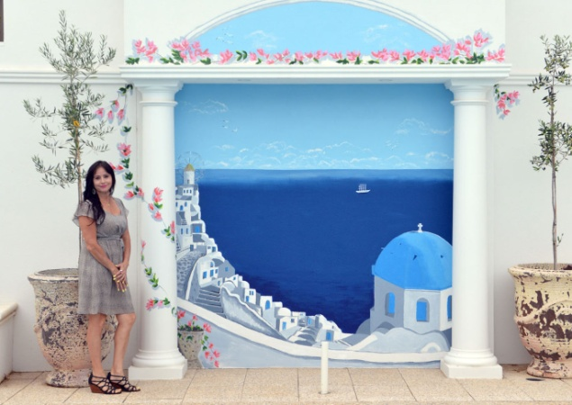

COMMUNITY SERVICE Interactive collaboration, designing huge mural with members of Bedford and voluntarily decorating Trott Park Community Centre. Aboriginal fostering and mentoring.

REVIEWS I have also been exposed through media such as Port Adelaide Messenger, The Parade, Advertiser, Adelaide Matters, Burkes Backyard, Sunday Mail, Murray Valley Standard and assorted workplace newsletters and Folk Art Magazine and the South East Messenger Press. As well as exhibiting publicly I exhibit at my Gallery/Studio in Norwood.

