Hyde & Seek 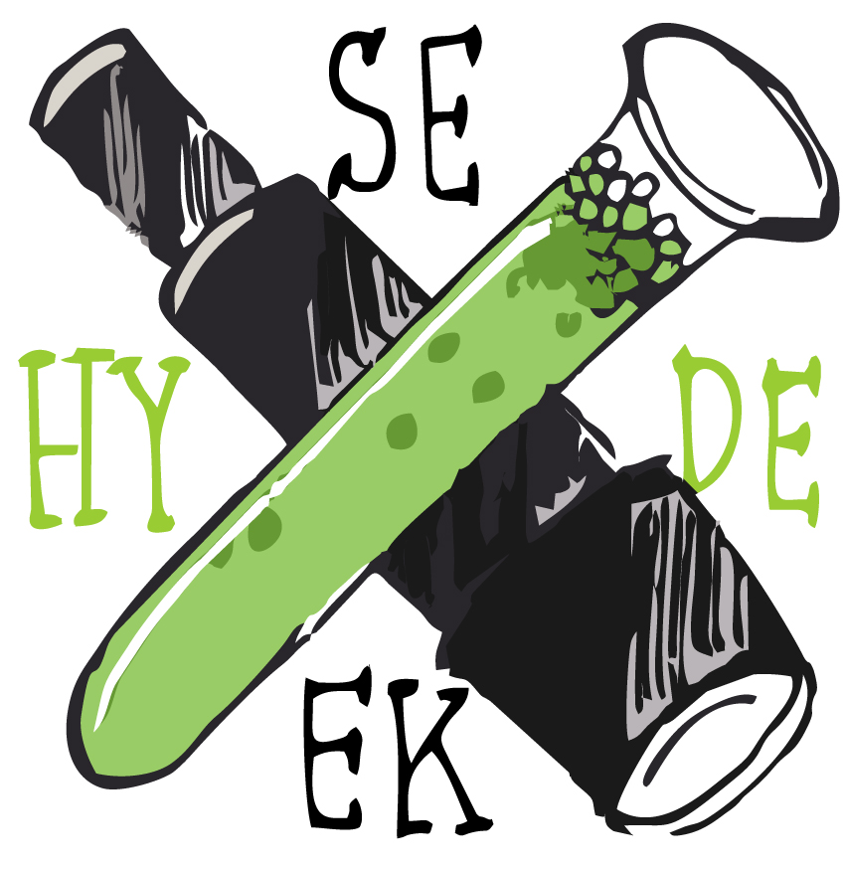
Street and Installation Artists: Simon Maglica and Dana Peters
Adelaide, South Australia
Email: hydeandseekarts@gmail.com

SUMMARY
Creative thinkers and passionate artist duo, finding unique and innovative uses for a variety of materials. From small things to big, turning everyday into art.

PROJECTS and ART PIECES
2017
Kiss the Ground, Bowden, S.A., Australia
(plastic cups)
Fork Unicorn, Playford, S.A, Australia
(plastic forks)

2015
Bred Zepplin, Berlin, Germany
(plastic bread tags)
Surviving Sunrise, Magill, S.A., Australia
(plastic cups)
Sparkle it Back, Bowden, S.A., Australia
(twine)

2014
Piece of Toast Palace, Bowden, S.A., Australia (bread)
The Battle, Norwood, S.A, Australia
(toy army men)

2013
Tiny Teddy Roosevelt, Norwood, S.A., Australia (biscuits)
When Eye See You, Bowden, S.A., Australia (plastic cups)
She Blows, Glen Osmond, S.A., Australia
(plastic cups)
Sign Alterations, various, S.A., Australia
(vinyl)
Bread Astaire, Norwood, S.A., Australia
(bread)
Chew Barrymore, Adelaide, S.A, Australia (handmade chewing gum)

COMMISSIONS
2016
Climbing Mountains, Art for the Heart Campaign, Australian Heart Foundation and Adelaide City Council,
Adelaide Railway Station, Adelaide, S.A. (aerosol, stencil, vinyl)
Lickety Split, Little Rundle Street Art Project,
Kent Town, S.A., Australia
(plastic cups)
Eyes on the Road, Coorong District Council,
Coonalpyn, S.A.
(fabricated metal tags)

2015
Home is Where the Heart Is, City Council of Holdfast Bay,
Glenelg, S.A., Australia
(plastic cups)

2014
Eye in the Sky, Renewal SA,
Bowden, S.A., Australia
(plastic fabricated pieces)

BIBLIOGRAPHY - Selection
Lou Chamberlain, Street Art Australia, Publisher: Hardie Grant Egmont Date: November 2015
Justin Crowe, Artist Duo Brighten Streets of Adelaide, Artme Gallery (blog), 12 February 2015 http://www.artmegallery.com.au/blog/projects-by-art-duo-hyde-seek-brighten-the-streets-of-adelaide/
Laura Caseley, This Art Will Stop You In Your Tracks.., Viralnova (blog), 11 February 2015 http://www.viralnova.com/hyde-and-seek/

